100 KM Route

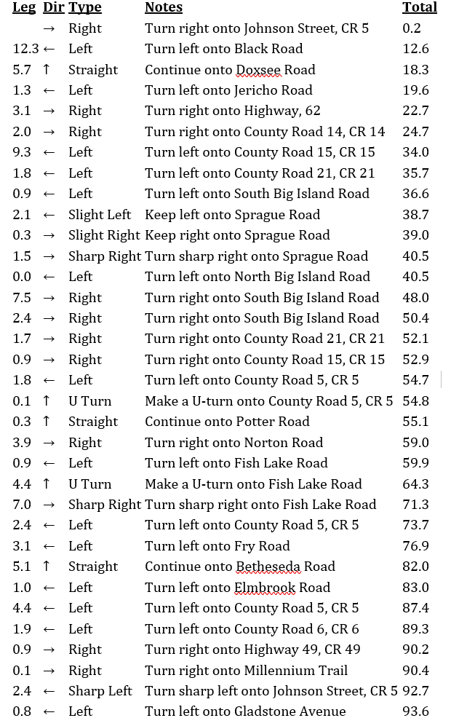
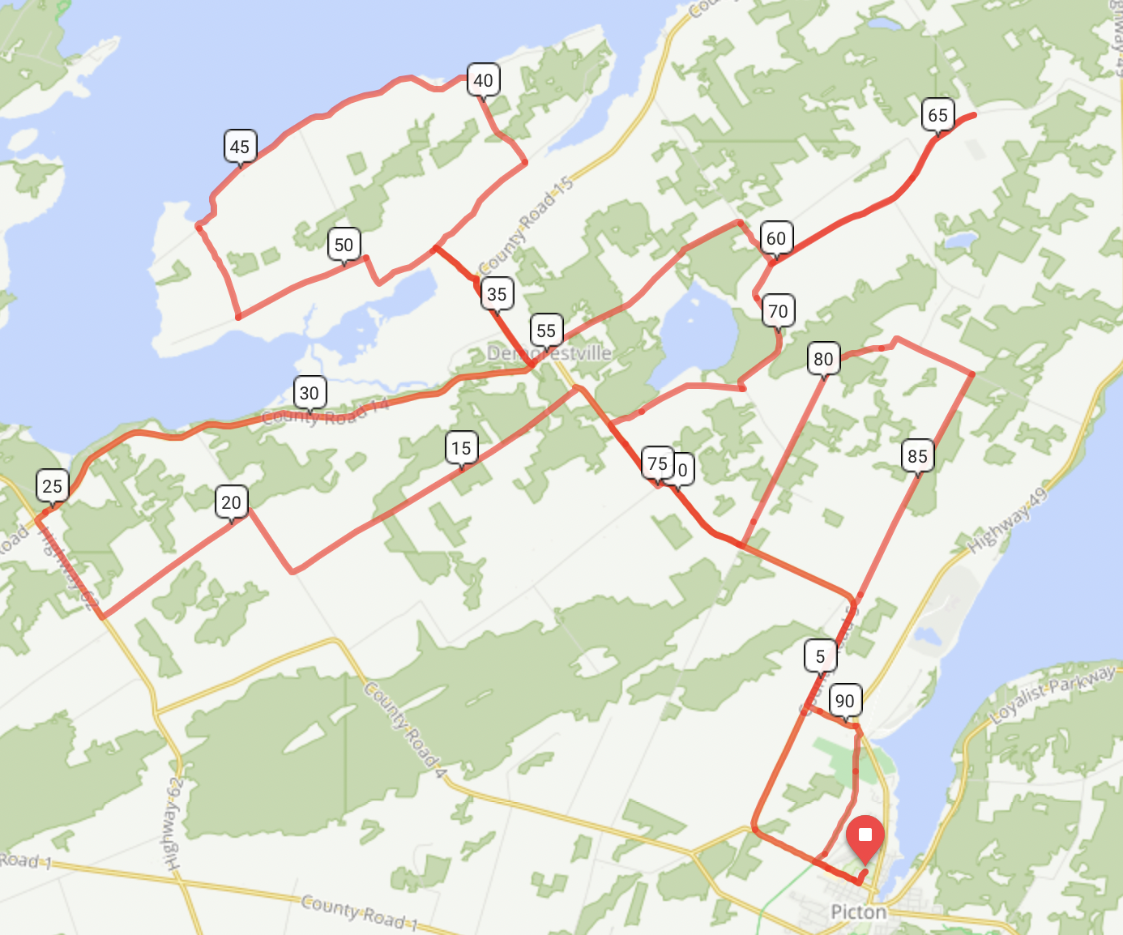
Event Day Contacts
Dave Wilder 613 921 6494
Don Leslie 613 323 2536
Glen Grossmith 416 270 9598

50 KM Route

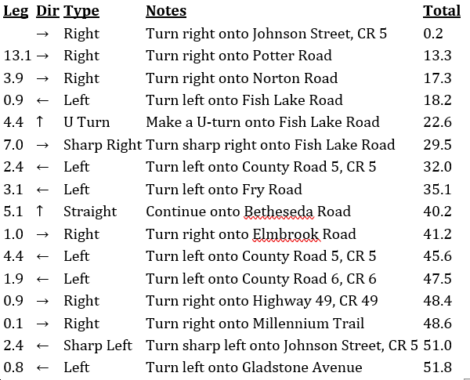
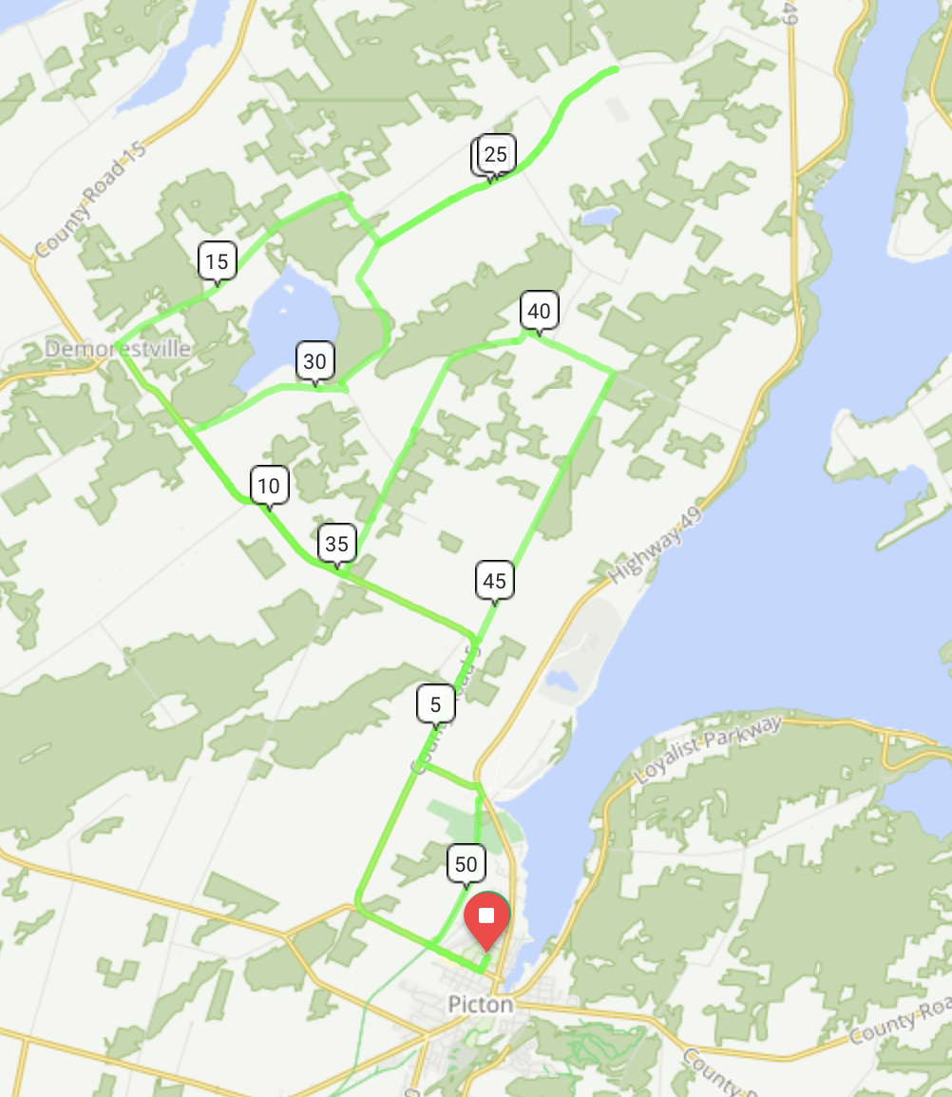
Event Day Contacts
Dave Wilder 613 921 6494
Don Leslie 613 323 2536
Glen Grossmith 416 270 9598

25 KM Route
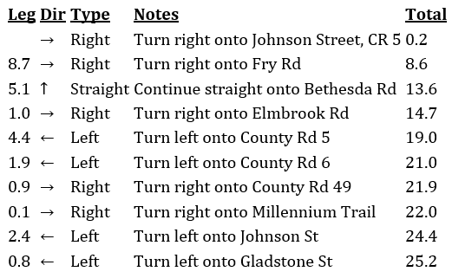
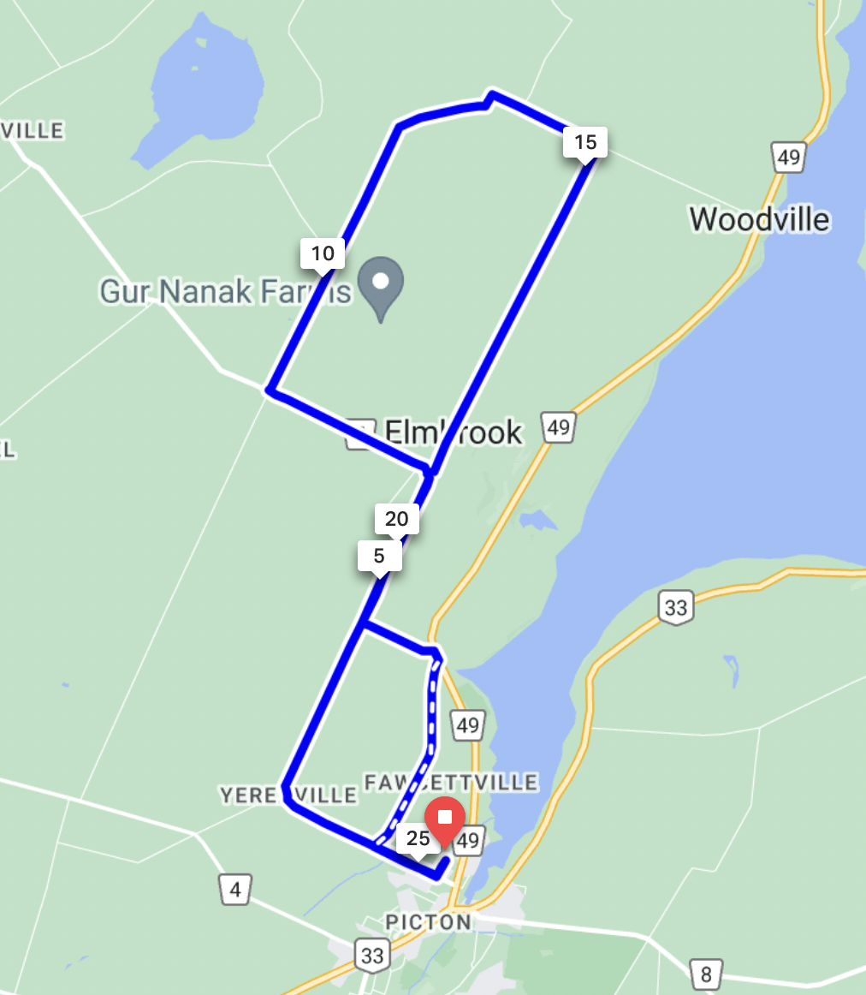
Event Day Contacts
Dave Wilder 613 921 6494
Don Leslie 613 323 2536
Glen Grossmith 416 270 9598

